Ex.no:8 | MINI PROJECT – SPORTS  DATA ANALYTICS

Domain and Problem Statement:
Domain: Sports Analytics & Performance Management
Problem Statement: Sports teams face performance challenges caused by inconsistent player statistics, varying match outcomes, and unoptimized performance strategies. This project addresses these challenges by transforming raw sports records into structured business intelligence across Power BI and Tableau to evaluate player performance, team trends, and match outcomes.

Dataset Description:
Dataset Name: Sports Analytics Dataset.
Granularity: Each row represents a single sports player or match performance record.
Timeframe Covered: Multiple seasons and match records.
Key Entities & Attributes:
- Player Details: player name, team, country, role, age.
- Performance Details: matches, runs, wickets, goals, assists, wins, losses.
- Statistics: shots, passes, tackles, player rating.
Data Source:
Primary Source: Kaggle Open Datasets (Sports Analytics Dataset).
Storage Infrastructure: Cleaned sports performance records hosted within a local MySQL database instance (sports_analytics).

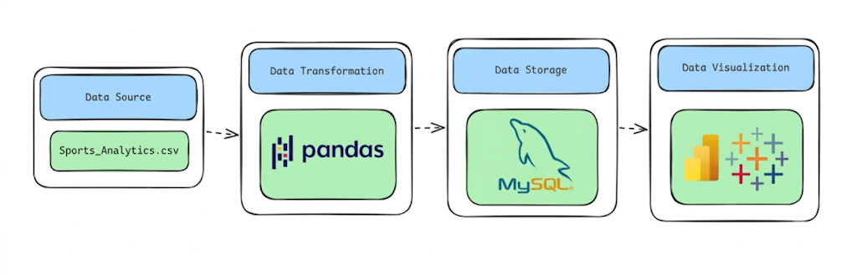
Architecture:

Program:
1. Python – Data Cleaning & Transformation
# ============================================================
# FINAL SPORTS ANALYTICS DATASET
# European Soccer Database
# ============================================================

# Start from the clean match dataframe
final_df = match.copy()
# 1. Keep only useful columns for Sports Analytics
final_columns = [
"match_api_id",
"country_name",
"league_name",
"season",
"stage",
"date",

"home_team_name",
"away_team_name",

"home_team_goal",
"away_team_goal",

"total_goals",
"goal_difference",
"match_result"
]

final_df = final_df[final_columns].copy()
# 2. Remove duplicate matches
final_df.drop_duplicates(
subset=["match_api_id"],
inplace=True

# 3. Handle missing values
# Text fields
text_columns = [
"country_name",
"league_name",
"season",
"home_team_name",
"away_team_name"
]

for column in text_columns:
final_df[column] = final_df[column].fillna("Unknown")

# Numeric fields
numeric_columns = [
"home_team_goal",
"away_team_goal",
"total_goals",
"goal_difference"
]

for column in numeric_columns:
final_df[column] = final_df[column].fillna(0)

final_df["date"] = pd.to_datetime(
final_df["date"],
errors="coerce"
)
# Year
final_df["year"] = final_df["date"].dt.year

# Month number
final_df["month"] = final_df["date"].dt.month

# Month name
final_df["month_name"] = final_df["date"].dt.month_name()

final_df["goal_category"] = pd.cut(
final_df["total_goals"],
bins=[-1, 1, 3, 5, float("inf")],
labels=[
"Low Scoring",
"Normal Scoring",
"High Scoring",
"Very High Scoring"
]
)

final_df["home_win"] = (
final_df["match_result"] == "Home Win"
).astype(int)

final_df["away_win"] = (
final_df["match_result"] == "Away Win"
).astype(int)

final_df["draw"] = (
final_df["match_result"] == "Draw"
).astype(int)
# 8. Standardize column names
final_df.columns = (
final_df.columns
.str.lower()
.str.strip()
.str.replace(" ", "_")
)
# 9. Sort by date
final_df.sort_values(
by="date",
inplace=True
)

final_df.reset_index(
drop=True,
inplace=True
)
# 11. Final validation
print("=" * 60)
print("FINAL SPORTS ANALYTICS DATASET")
print("=" * 60)

print(f"Rows : {final_df.shape[0]:,}")
print(f"Columns : {final_df.shape[1]}")

print("\nDuplicate Match IDs:")
print(final_df["match_api_id"].duplicated().sum())

print("\nMissing Values:")
print(final_df.isnull().sum())

print("\nData Types:")
print(final_df.dtypes)
print("\nFirst 5 Records:")
display(final_df.head())
# 12. Export CSV
output_file = "European_Soccer_Sports_Analytics_Cleaned.csv"
final_df.to_csv(
output_file,
index=False
)
print("\n" + "=" * 60)
print(f"CSV CREATED: {output_file}")
print("=" * 60)
# 13. Download
from google.colab import files
files.download(output_file)

2. MySQL – Database and Data Loading
MySQL Command Prompt:
net start MySQL80
mysql -u root -p
MySQL:
CREATE DATABASE IF NOT EXISTS hotel_analytics;
Python/Jupyter:
username = "root"
password = "YOUR_MYSQL_PASSWORD"
host = "localhost"
port = 3306

# Connect to MySQL database
db_engine = create_engine(
f"mysql+pymysql://{username}:{password}@{host}:{port}/Sports_analytics"
)
sports.to_sql(
"football_matches",
con=db_engine,
if_exists="replace",
index=False,
chunksize=5000
)
print("Data loaded successfully into MySQL!")
Verify:
result = pd.read_sql(
"SELECT COUNT(*) AS total_rows FROM football_matches",
db_engine
)
display(result)

Procedure:
Step 1: Data Preparation & Preprocessing (Python / Pandas)
- Load the raw Soccer Analytics dataset into a Jupyter Notebook / Python script using pandas.read_csv().
- Inspect for null values and handle missing data in player, team, and position columns.
- Feature engineer total player contributions by combining goals and assists:
Total Contributions = Goals + Assists
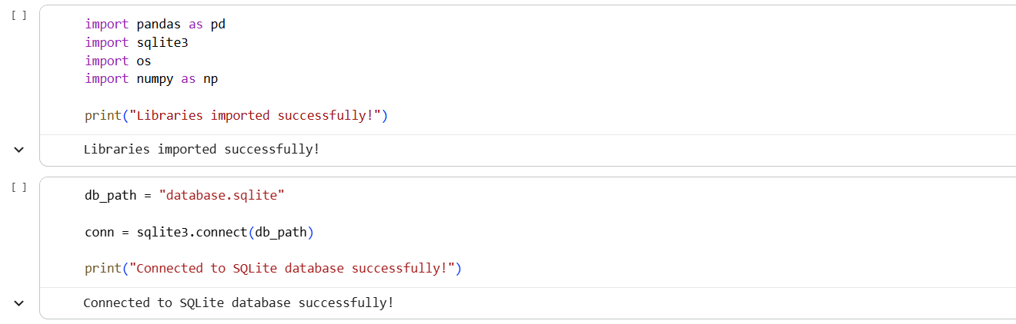
- Filter out invalid rows (e.g., zero total guests or negative ADR entries) and export the cleaned DataFrame to MySQL using sqlalchemy and to_sql().
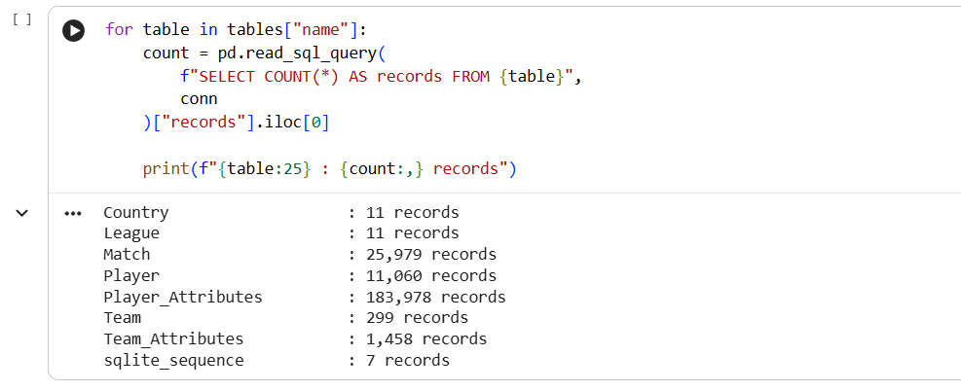
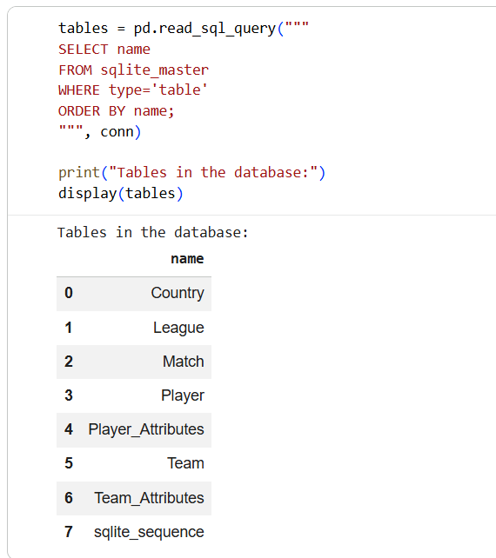

Step 2: SQL Database Connection & Data Ingestion
- Open Power BI Desktop $→$ Click Get Data $→$ Select MySQL Database.
- Enter the Server (localhost:3306) and Database Name (Sports_analytics).
- Enter authentication credentials, select the cleaned flat table (sports_analytics / sports_performance), and click Transform Data to open Power Query
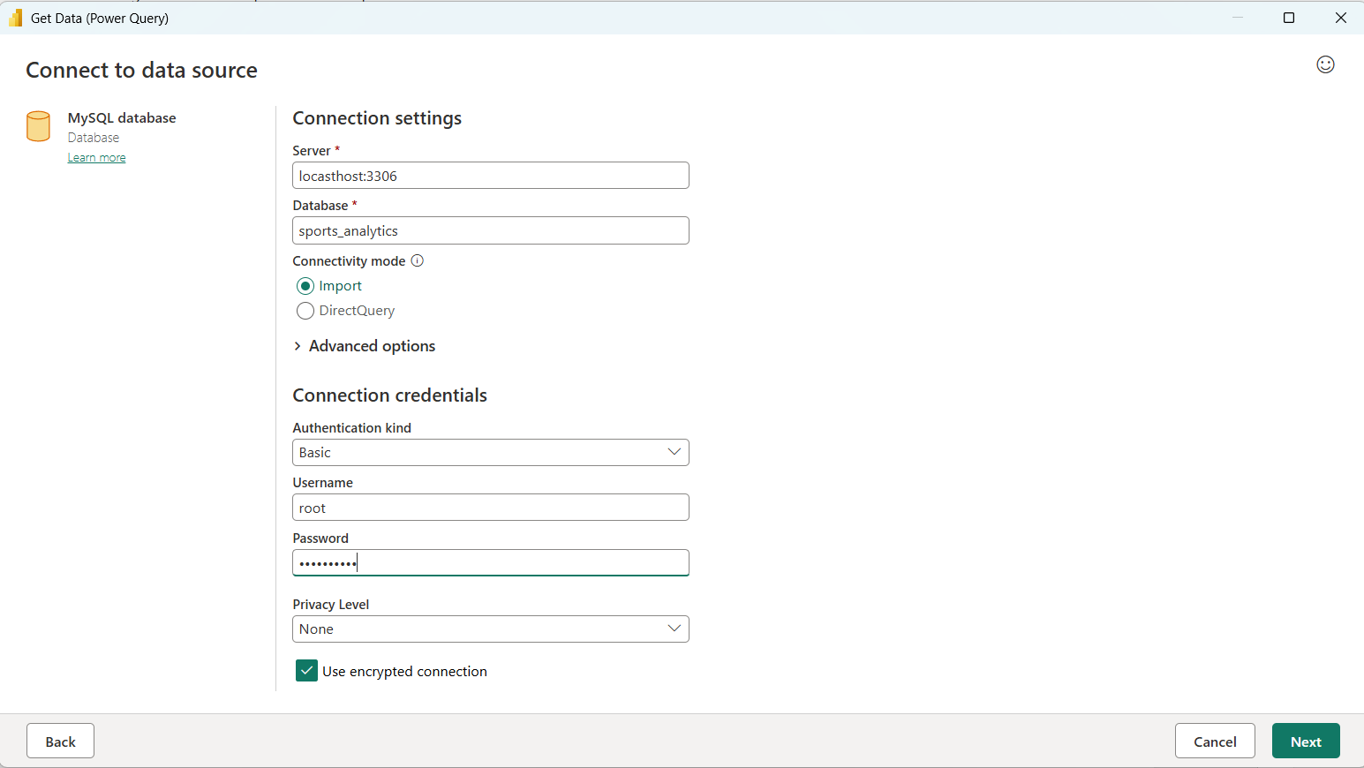

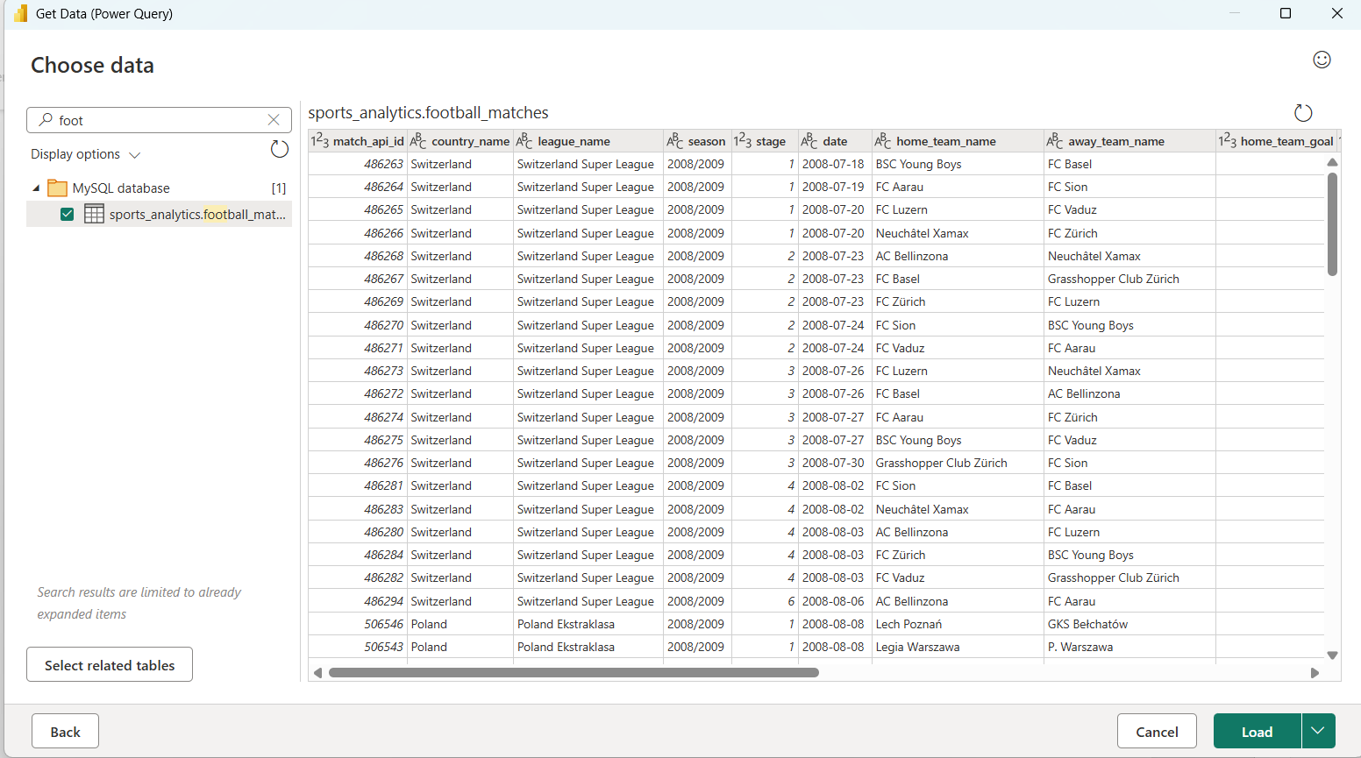

Step 3: Star Schema Data Modeling (Power BI)
• Table Splitting in Power Query:
- Duplicate the imported flat table (sports_performance) four times to create separate entities: Fact_Performance, Dim_Player, Dim_Team, and Dim_Date.
- In Dim_Player, keep player_name, position, age, and country. Remove duplicates and add an Index Column as PlayerID.
- In Dim_Team, keep team. Remove duplicates and add an Index Column as TeamID.
- In Fact_Performance, merge with dimension tables to map PlayerID and TeamID, then remove raw text columns.
- Click Close & Apply.
• Establishing Relationships in Model View:
- Open the Model View tab in Power BI.
- Connect Dim_Player[PlayerID] → Fact_Performance[PlayerID].
- Connect Dim_Team[TeamID] → Fact_Performance[TeamID].
- Connect Dim_Date[Date] → Fact_Performance[match_date].
- Hide foreign key columns inside Fact_Performance to keep the report fields pane organized.
Step 4: Core Calculations & Measures (DAX)
Power BI Measures (DAX)
Create a dedicated _Measures table and add the following DAX calculations:

- Average Goals Per Match:
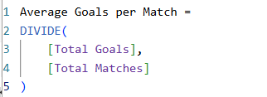

- Away Win %
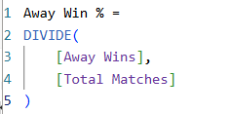

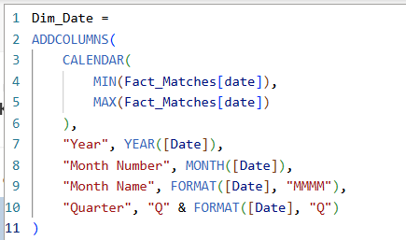
- Date

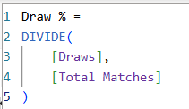
- Draw

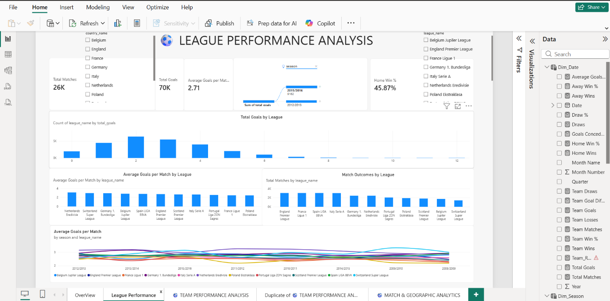
Step 5: Power BI Final Executive Dashboard & Drill-Through

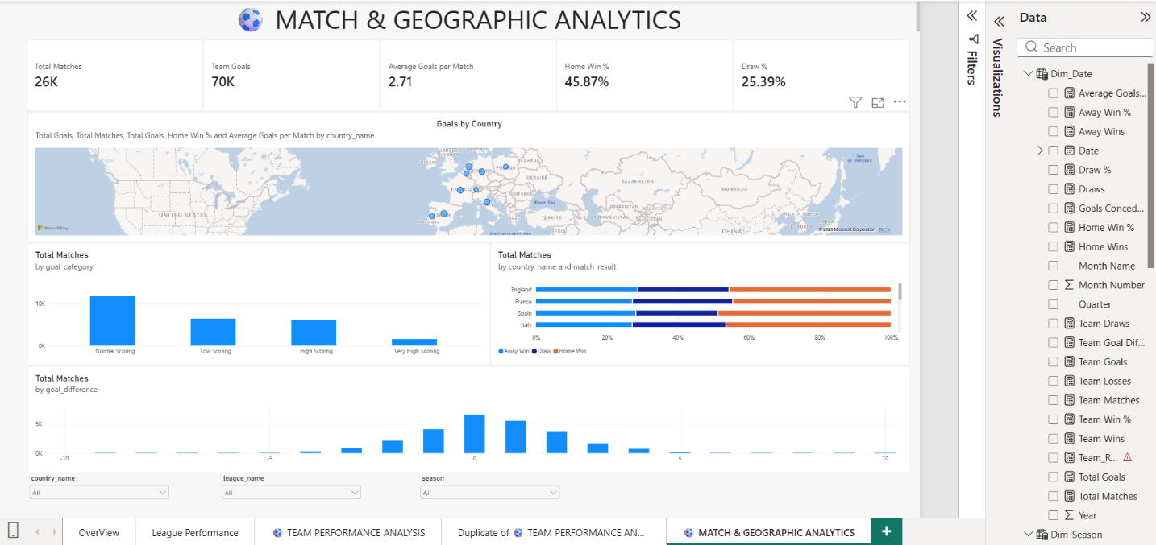
- Executive Canvas:
  - Place Card Visuals across the top: Total Matches, Team Goals, Average Goals per Match, Home Win % , Draw%.

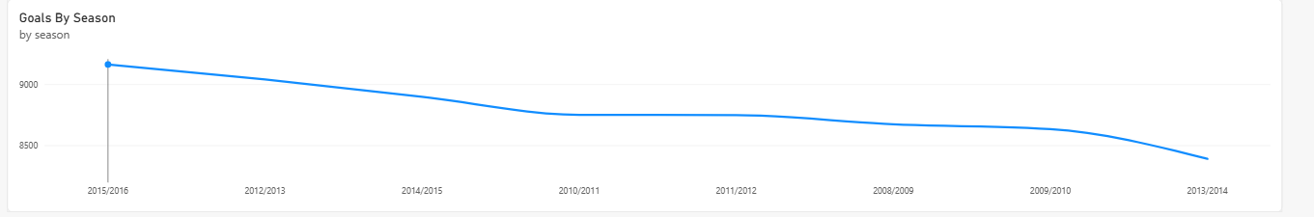
  - Add a Line Chart mapped to Goals By Season with hierarchy drill-down enabled (Year $→$ Quarter $→$ Month).

  - Add a Clustered Bar Chart for Total Goals by League :
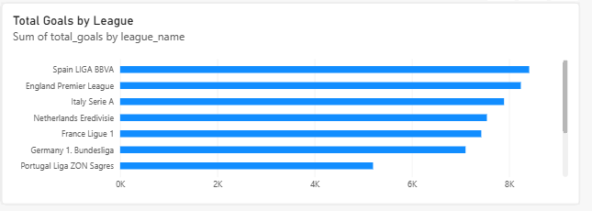

  - Add Slicers for league_name , seasons
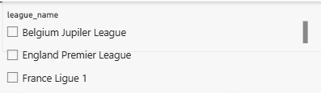

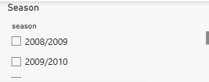

Step 6: Tableau Data Connection & Preparation
- Open Tableau Desktop / Tableau Public.
- Under To a Server, select MySQL
- Enter Server (localhost), Database (sports_analytics), and user credentials to pull the cleaned dataset onto the canvas.
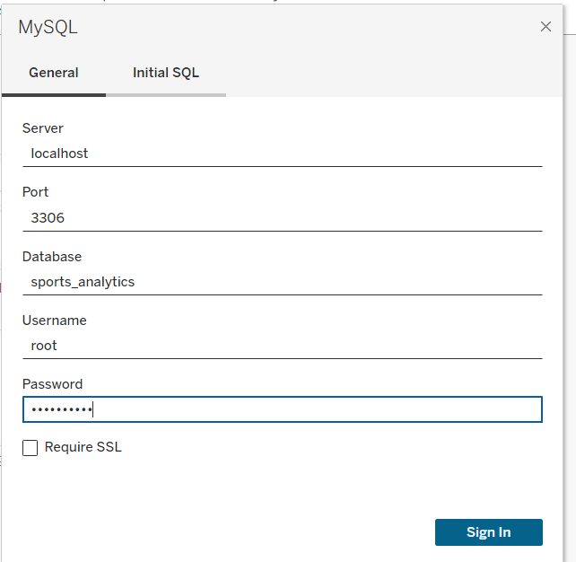

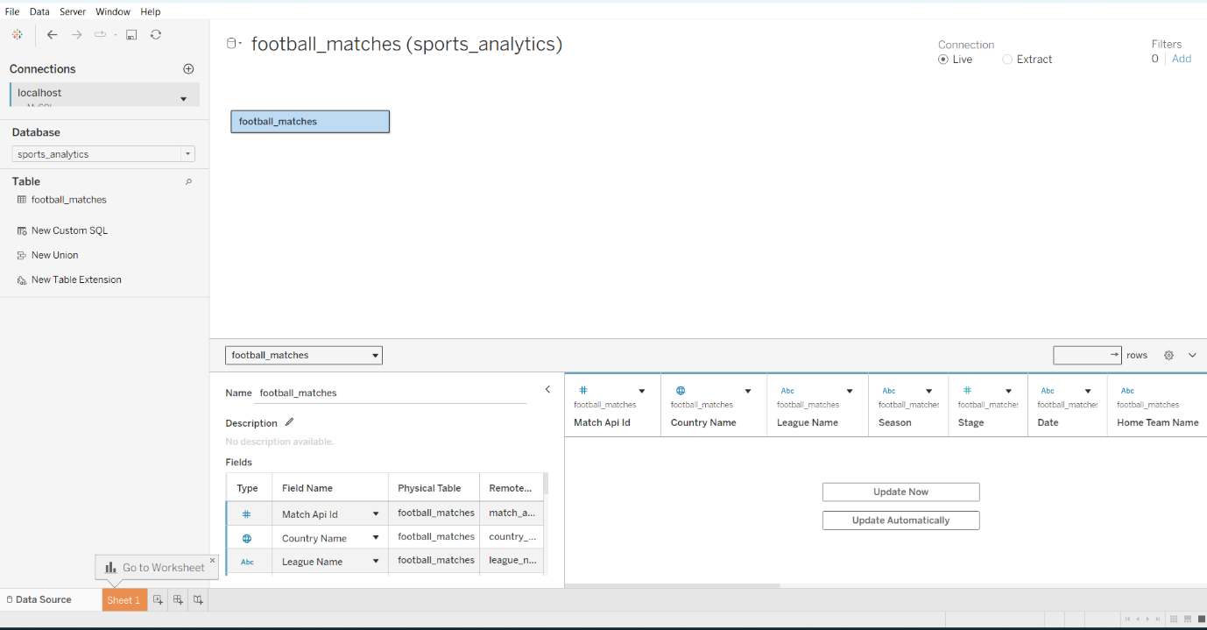

- Go to any sheet and build calculated fields:
  - Select Metric Parameter: String list containing "Total Goals", "Average Goals", "Home Wins","Away Wins".
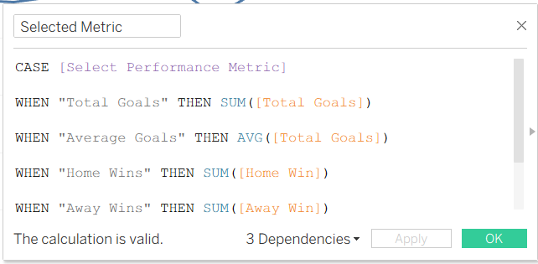

  - Home Win %:
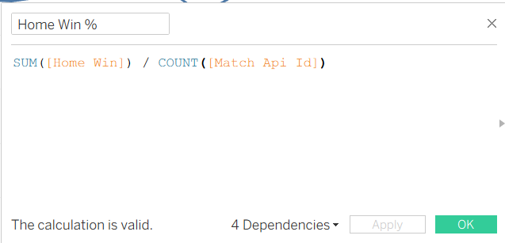

  - Away Win %:
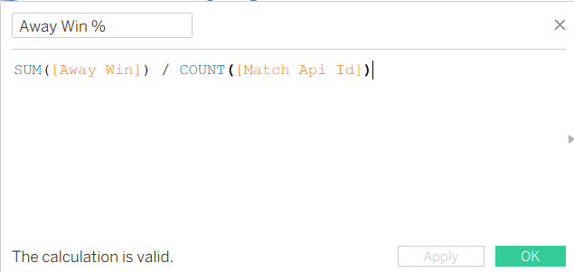

Step 7: Tableau Companion Dashboard & Interactive Story

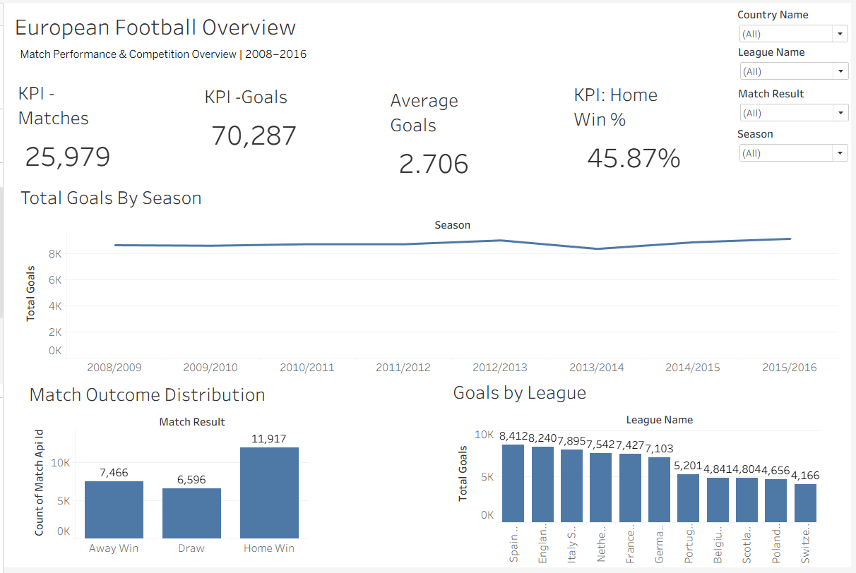
  - European Football Overview:

  - Goals By League :
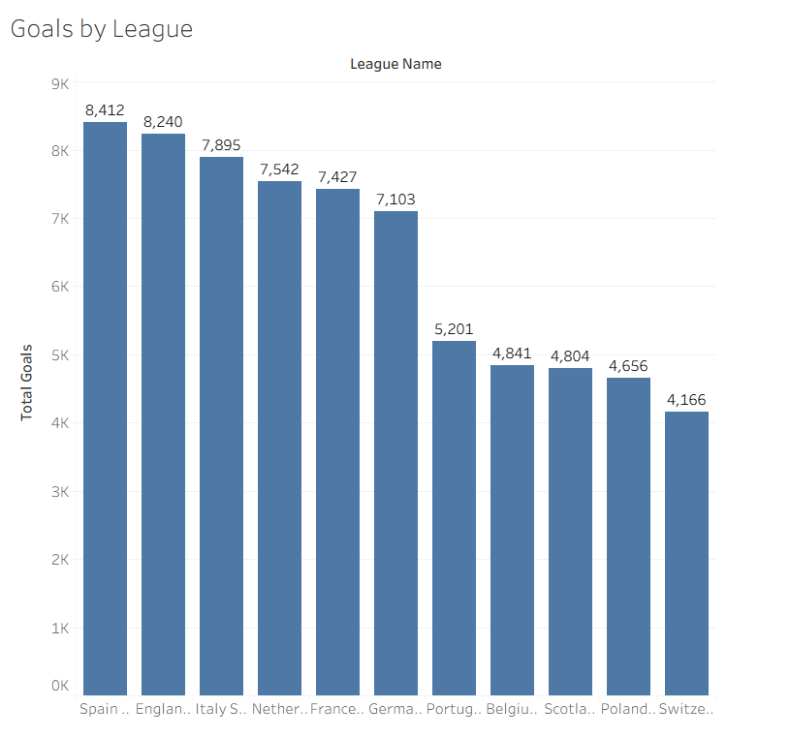

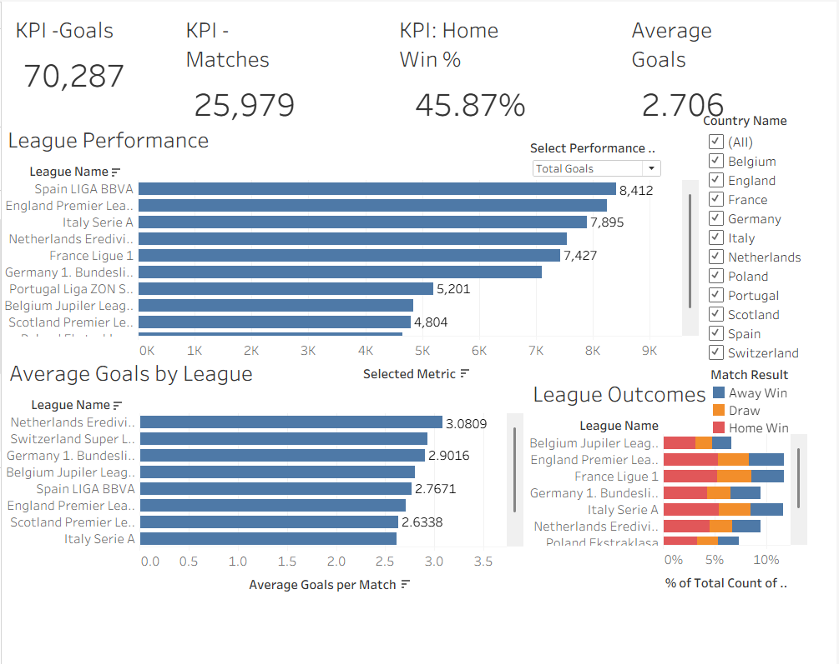
- League Analytics :

- League Outcomes:
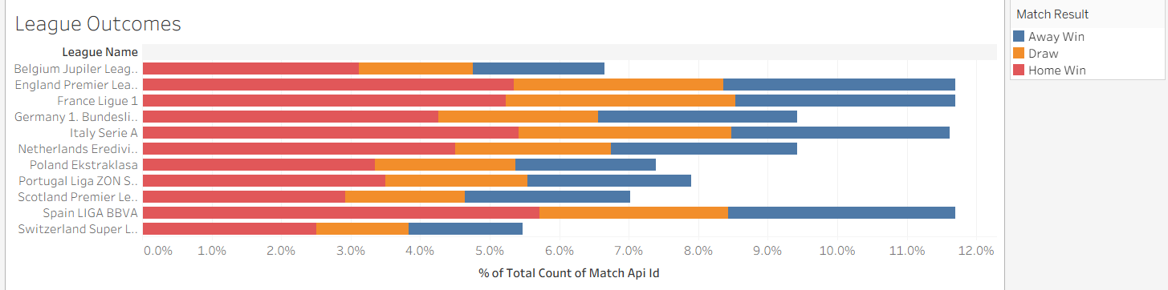

- League Scoring Trend :

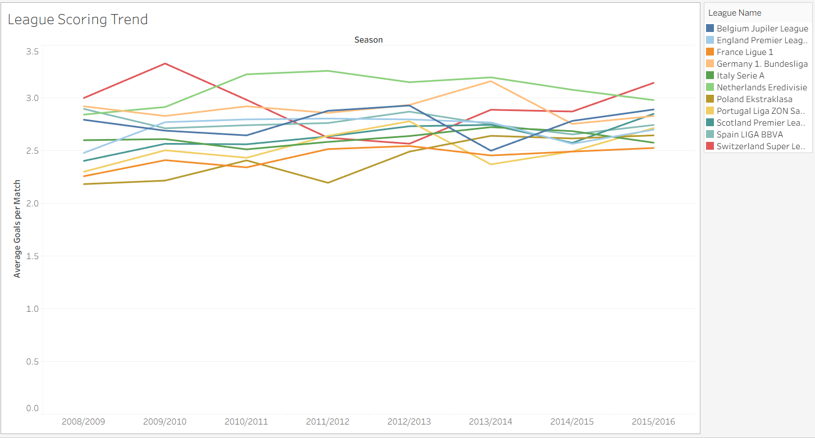
Observed Insights:

- Portfolio Overall Performance & Player Contributions: The dataset captures overall match performance and player contributions, with key metrics including goals, assists, matches played, and player ratings.
- Team Performance: Performance varies across teams, with some teams demonstrating higher win rates and stronger player contributions compared to others.
- Seasonal Trends: Player and team performance fluctuate across the season, with changes in goals, assists, wins, and match outcomes across different periods.
- Player Performance Distribution: A small group of top-performing players contributes significantly to overall goals, assists, and ratings, highlighting key players who have the greatest impact on team performance.

RESULT:
The Sports Analytics mini project was successfully implemented using Python, MySQL, Power BI, and Tableau. A sports performance dataset was processed using Python and stored in MySQL. The data was successfully analyzed and visualized using Power BI and Tableau through bar charts, line charts, pie charts, and performance dashboards. The dashboard provides insights into player performance, team-wise results, goals, assists, match outcomes, and player ratings.

Final Result:
Sports Dataset
↓
Python Data Processing
↓
Cleaned CSV Dataset
↓
MySQL Database
↓
Data Verified
↓
Power BI & Tableau Connection
↓
Charts & Visualizations
↓
Interactive Dashboard
↓
Sports Analytics Completed

CONCLUSION:
Thus, the sports performance dataset was successfully cleaned, stored, managed, analyzed, and visualized using Python, MySQL, Power BI, and Tableau. The project demonstrates how data analytics and visualization techniques can be used to evaluate player performance, team trends, and match outcomes and identify meaningful patterns in sports data.

